
DEPARTMENT OF CSE
PROJECT ABSTRACT SUBMISSION
COURSE: PROJECT EVALUATION (24CS2235F) A.Y. 2026 - 2027
TITLE OF THE PROJECT | Intermediate Code Generator
S. No. | University ID | Name
1 | 2420030098 | B. Chetna Chaudhary
2 | 2420030647 | Aashna Begum
3 | 2420030740 | M. Asleshitha
4 | 2420030785 | K.Vasavi
Name of the Guide |  | E.UMA SHANKARI

Abstract

The Intermediate Code Generator is a Compiler Design project developed to convert high-level programming expressions into an intermediate representation that can be easily processed by the subsequent stages of a compiler. The main objective is to generate Three Address Code (TAC) from arithmetic expressions using Syntax Directed Translation and represent the generated code using Quadruples and Triples. The system accepts expressions as input, analyzes their structure, and produces a sequence of intermediate instructions using temporary variables. It also displays the corresponding Quadruple and Triple tables, helping users understand how expressions are translated into intermediate code. The project will be implemented using Python, which will be used for expression parsing, syntax-directed translation, TAC generation, and table representation. The system will handle common arithmetic operators and operands while maintaining the correct order of operations. It provides a clear visualization of the intermediate representation and helps in understanding the relationship between source code and machine-level code. The project can also be extended in the future to support more complex expressions, additional operators, and other intermediate-code representations. Overall, the project provides a practical understanding of the Intermediate Code Generation phase of a compiler and demonstrates how high-level code is transformed into an efficient and structured intermediate form.

Project Architecture/Project Overview:

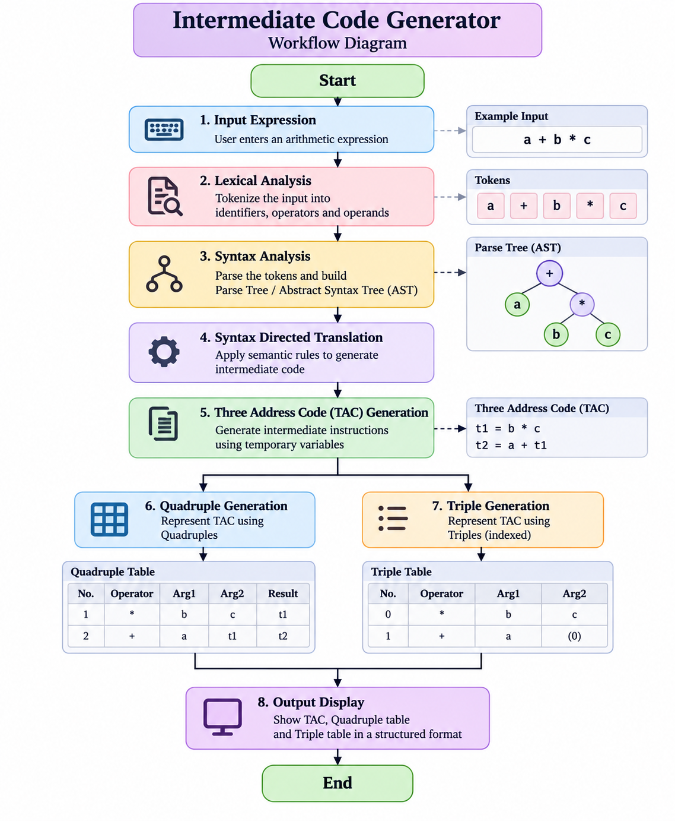
Expected Outcome
The final system will allow a user to enter an arithmetic expression and automatically generate its corresponding TAC, Quadruple representation, and Triple representation. This provides a practical demonstration of the Intermediate Code Generation phase of a compiler and shows how high-level expressions are transformed into a structured intermediate form.

Signature of the Guide HOD

